Assignment-7.3
M.Shivamani
2303A52344
Batch-38

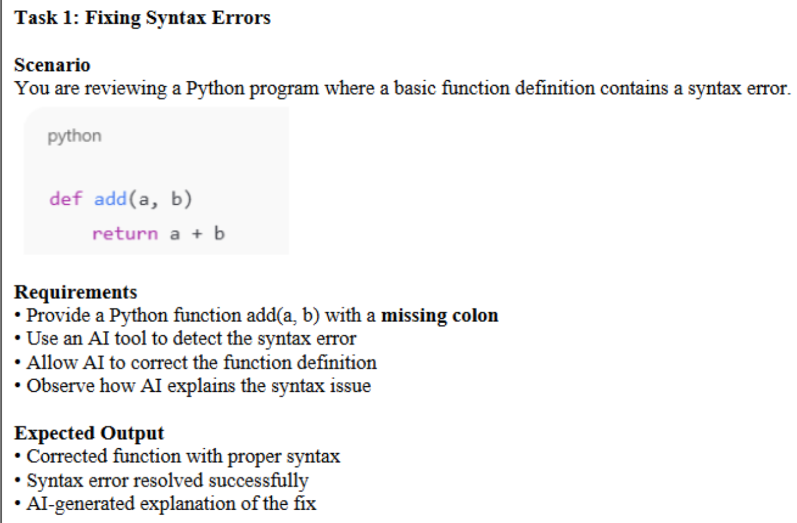
Code
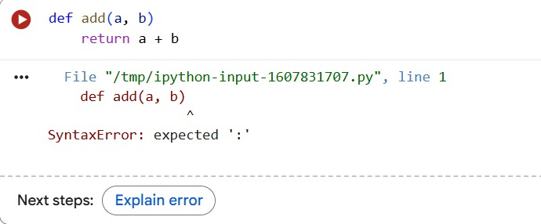
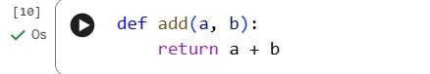

AI-generated explanation of the fix
The error 'SyntaxError: expected ':' means that you are missing a colon at the end of the def add(a, b) line. Python requires a colon to mark the start of a function's code block. I will fix this by adding a colon to the function definition.

The code def add(a, b): return a + b was executed successfully. This action defines the add function, making it available for use in subsequent cells. As this cell only defines the function and does not call it or print anything, there is no direct output.
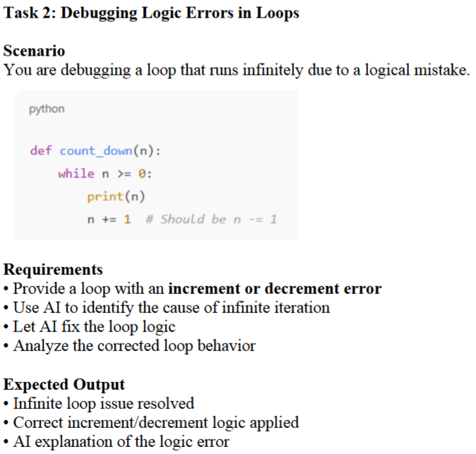
Code
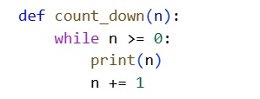
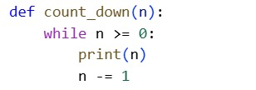

AI explanation of the logic error
The program runs but does not terminate because the loop variable is incremented instead of decremented.
This causes an infinite loop, which is a logic error and not detected by the Python interpreter.
Since the loop condition n >= 0 always remains true, the stopping condition is never reached.
This demonstrates how logical mistakes can lead to incorrect program behavior even when no syntax or runtime errors are reported.

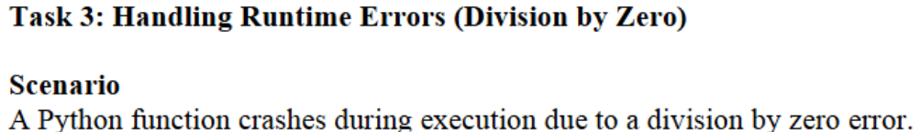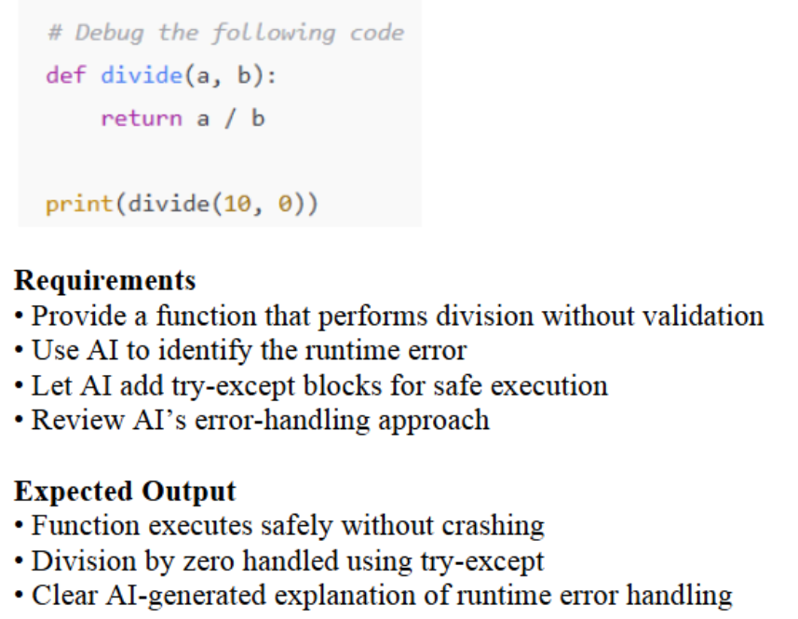

Code
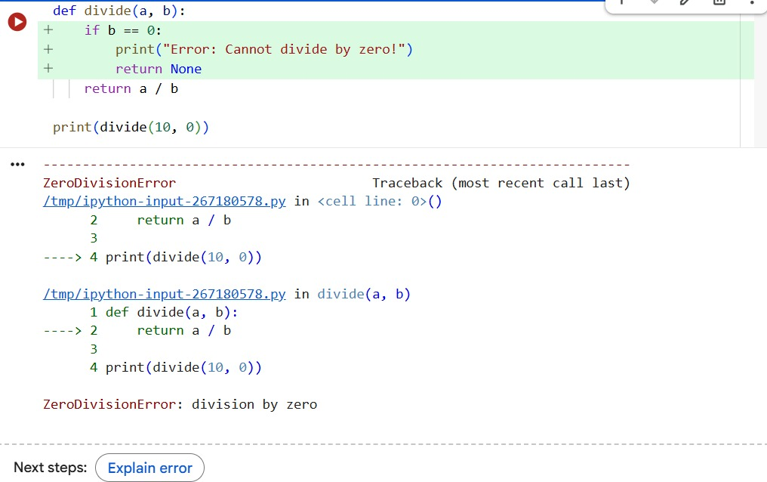
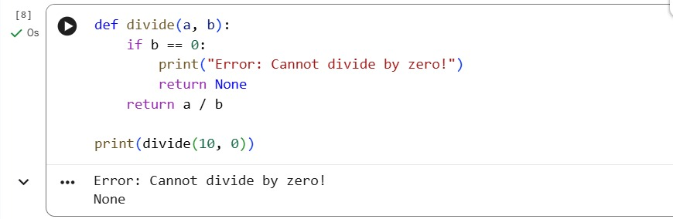

Clear AI-generated explanation of runtime error handling
You're encountering a ZeroDivisionError because the code is trying to divide 10 by 0. Division by zero is not allowed in mathematics or programming. I'll modify the divide function to handle this case by checking if the divisor is zero before performing the division.

The code in cell lwYSZTOy5Evf executed successfully. Your divide function now correctly handles division by zero by printing "Error: Cannot divide by zero!" and returning None, which is then printed to the output.
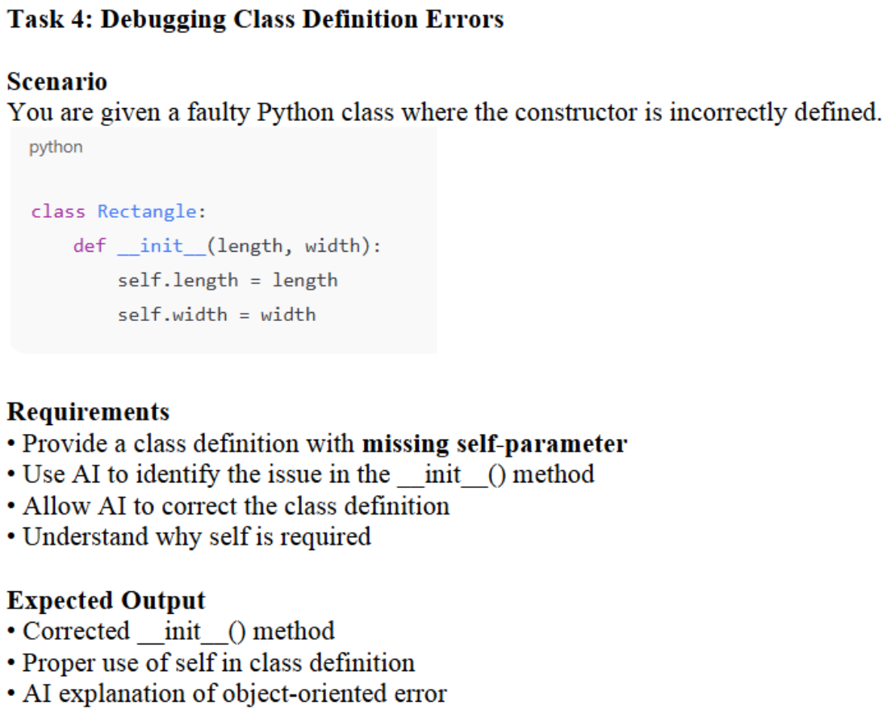

Code
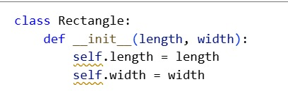
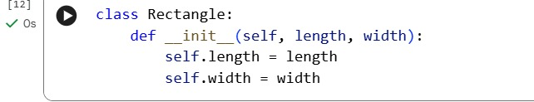
AI explanation of object-oriented error
The error occurs because the __init__() method is defined without the self parameter.
In Python, self refers to the current object and is automatically passed to instance methods.
Without self, instance variables cannot be accessed or assigned, leading to incorrect object initialization.
Adding self to the constructor allows the class to properly store and access object attributes.
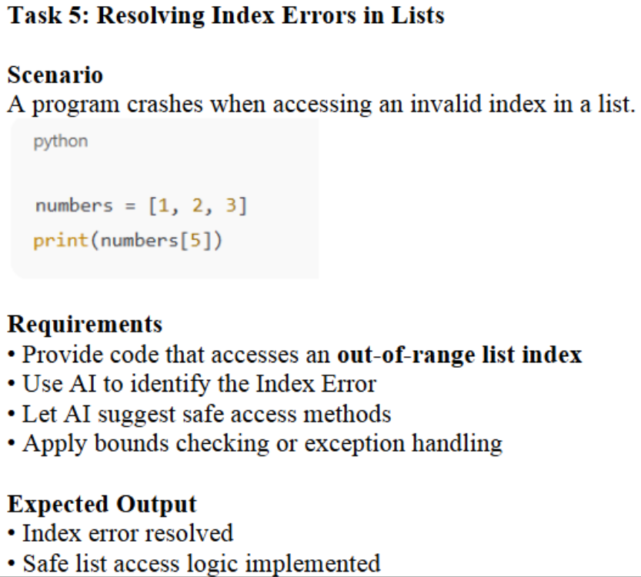

Code
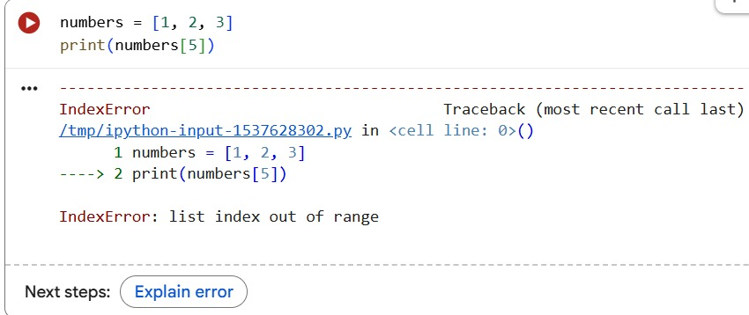
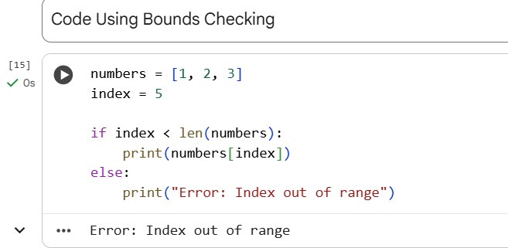
Explanation
The error occurs when the program attempts to access a list index that is outside the valid range.
Bounds checking ensures that the index value is within the list length before accessing the element.
By verifying the index using len(), the program prevents an IndexError at runtime.
This approach ensures safe list access and improves the reliability of the program.

